Actividad StatelessWidgets

main.dart

import 'package:flutter/material.dart';
import 'SecondPage.dart';

void main() {
runApp(MyApp());
}

class MyApp extends StatelessWidget {
const MyApp({super.key});

@override
Widget build(BuildContext context) {
return MaterialApp(
debugShowCheckedModeBanner: false,
home: FirstRoute(),
);
}
}
class FirstRoute extends StatelessWidget {
final List<String> texto = [
'Bienvenido a la aplicación',
'de Samuel Alejandro Arboleda Mesa ',
'este es la actividad 2 de flutter que',
'se trata de navegar entre pantallas',
'Presiona el botón para continuar'
];

FirstRoute({super.key});

@override
Widget build(BuildContext context) {
return Scaffold(
appBar: AppBar(
title: const Text('Carro wallpaper'),
centerTitle: true,
backgroundColor: Colors.lightBlue,
),
body: Column(
mainAxisAlignment: MainAxisAlignment.center,
children: [
const Image(
image: NetworkImage(
'https://wallpapers.com/images/featured/coche-4k-yduvczxgolxxu1nk.jpg',
),
height: 200,
),
const SizedBox(height: 20),
for (var line in texto)
Padding(
padding: const EdgeInsets.symmetric(vertical: 6),
child: Text(
line,
style: const TextStyle(
fontSize: 18,
fontWeight: FontWeight.w500,
),
textAlign: TextAlign.center,
),
),
const SizedBox(height: 30),
ElevatedButton(
style: ElevatedButton.styleFrom(
backgroundColor: Colors.lightBlueAccent,
padding:
const EdgeInsets.symmetric(horizontal: 40, vertical: 15),
shape: RoundedRectangleBorder(
borderRadius: BorderRadius.circular(12),
),
),
onPressed: () {
Navigator.push(
context,
MaterialPageRoute(builder: (context) => SecondRoute()),
);
},
child: const Text(
'Hola',
style: TextStyle(color: Colors.white, fontSize: 16),
),
),
const SizedBox(height: 30),
],
),
);
}
}
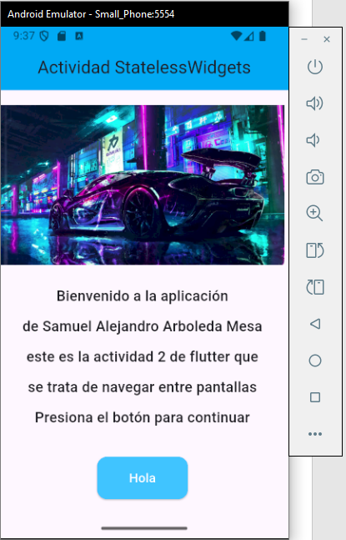

SecondPage.dart

import 'package:flutter/material.dart';

class SecondRoute extends StatelessWidget {
const SecondRoute({super.key});

@override
Widget build(BuildContext context) {
return Scaffold(
appBar: AppBar(
title: const Text(
'Segunda ruta',
style: TextStyle(color: Colors.white),
),
centerTitle: true,
backgroundColor: Colors.redAccent,
),
body: Center(
child: ElevatedButton(
style: ElevatedButton.styleFrom(
backgroundColor: Colors.redAccent,
padding: const EdgeInsets.symmetric(horizontal: 40, vertical: 15),
shape: RoundedRectangleBorder(
borderRadius: BorderRadius.circular(12),
),
),
onPressed: () {
Navigator.pop(context);
},
child: const Text(
'Adiós',
style: TextStyle(
color: Colors.white,
fontSize: 16,
fontWeight: FontWeight.w500,
),
),
),
),
);
}
}

